No. | Answer
 | It changes straight from solid to gas without passing through the liquid phase.
 | It dissolves in water to produce a weak acid: CO₂(g) + H₂O(l) → H₂CO₃(aq)
a C₆H₁₂O₆(aq) + 6O₂(g) → 6CO₂(g) + 6H₂O(l)
b In the mitochondria of cells
n(C₆H₁₂O₆) = 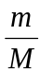 = 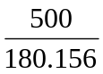 = 2.775
n(CO₂) = 6 × n(C₆H₁₂O₆) = 6 × 2.775 = 16.65 mol
∴ m(CO₂) = n × M = 16.65 × 44.01 = 732.8 g
∴ per week = 7 × 732.8 = 5.13 × 10³ g
a CaCO₃(s) 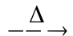CaO(s) + CO₂(g)
b CH₄(g) + 2H₂O(g) → 4H₂(g) + CO₂(g)
a 2HNO₃(aq) + Li₂CO₃(s) → 2LiNO₃(aq) + CO₂(g) + H₂O(l)
b n(Li₂CO₃) = = 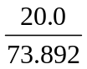 = 0.2707
n(HNO₃) = 2 × n(Li₂CO₃) = 2 × 0.2707 = 0.5414 mol
∴ V(HNO₃) = = 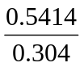 = 1.78 L
a n(CO₂) = = 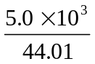 = 114
n(CH₄) = n(CO₂) = 114
∴ m(CH₄) = n × M = 114 × 16.042 = 1.8 × 10³ g = 1.8 kg
b Combustion/redox
a 2C₄H₁₀(g) + 13O₂(g) → 8CO₂(g) + 10H₂O(l)
b n(C₄H₁₀) in 2 hours = 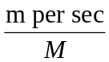 × time = 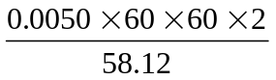 = 0.619
n(O₂) = 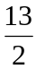 × n(C₄H₁₀) = 4.02
m(O₂) = n × M = 4.02 × 32.0 = 1.3 × 10² g
 | H⁺(aq) + HCO₃–(aq) → H₂O(l) + CO₂(g)
a C₆H₁₂O₆(aq) → 2CH₃CH₂OH(aq) + 2CO₂(g)
b Fermentation

